FACTORY METHOD PATTERN IMPLEMENTATION IN JAVA
The Factory Method Pattern is a Creational Design Pattern that provides an interface for creating objects without specifying their exact class.
KEY POINTS IN CODE:
- Shape Interface defines a common method draw().
- Circle and Rectangle implement the Shape interface.
- ShapeFactory creates and returns the required object based on user input.
- The Main class requests objects from the factory instead of creating them directly.

CODE:-
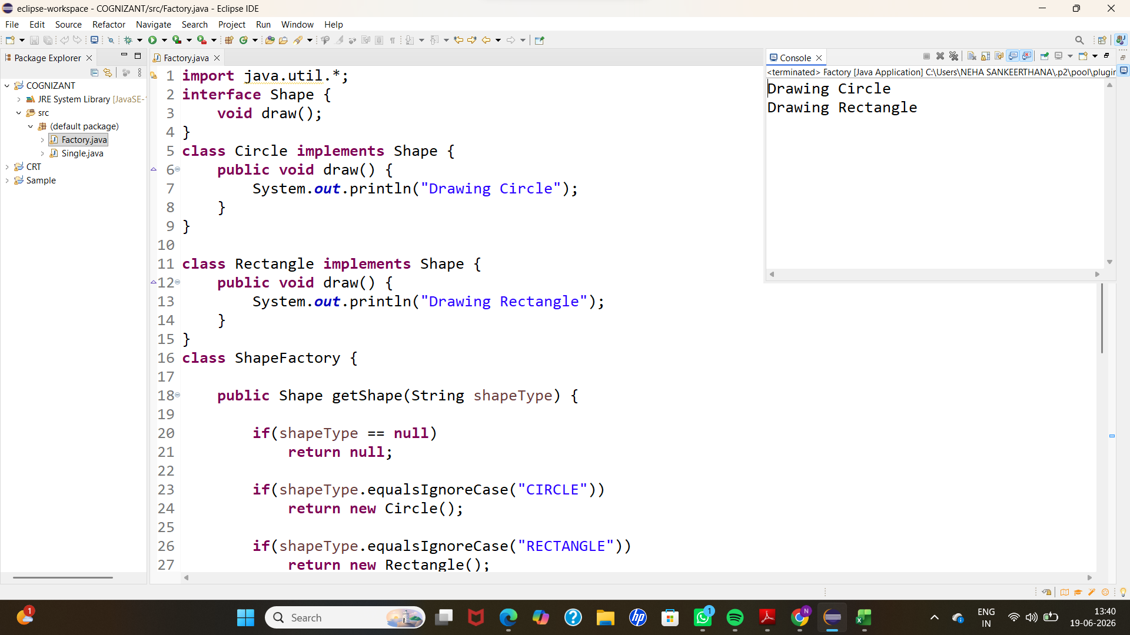

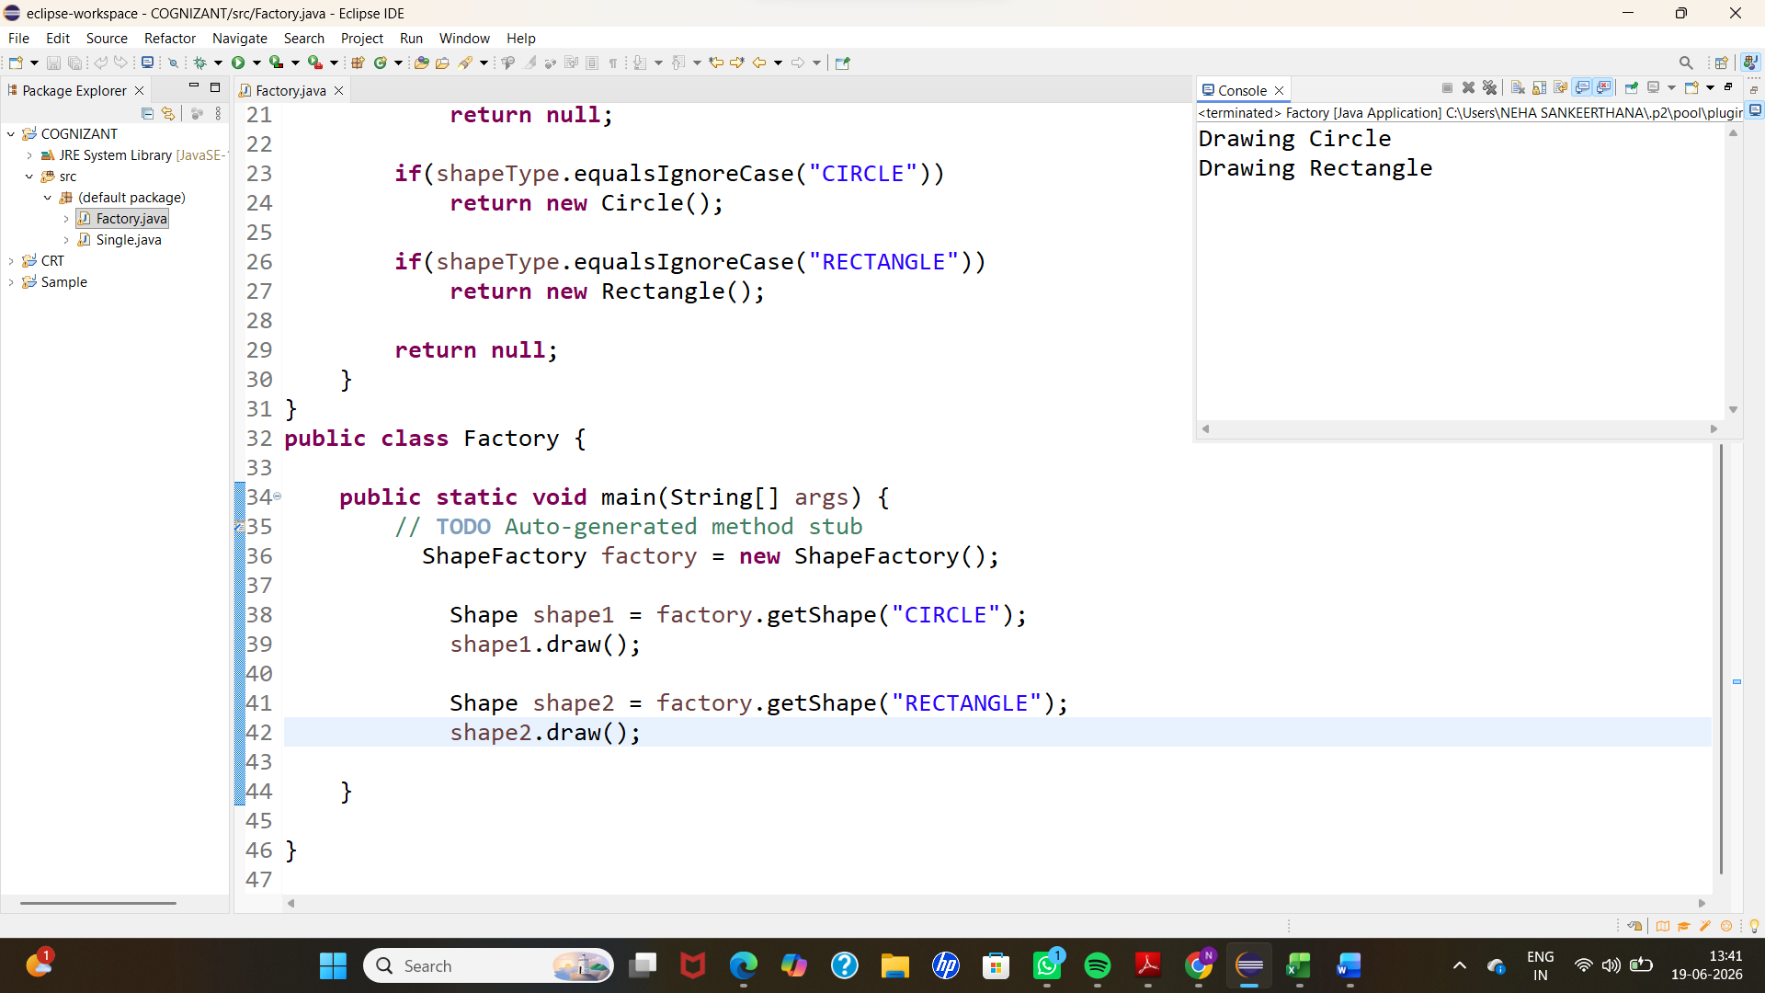
OUTPUT:-
